**Experiment No.: 1**

**Aim:** Program to perform matrix operations. Use NumPy as the python library and perform the operations using built in functions in NumPy.

**CO1:** Use different python packages to perform numerical calculations, statistical computations and data visualization.

**Procedure**:

import numpy as np

def input_matrix(ourmatrix):

r = int(input(f"Enter the no of rows for {ourmatrix}:"))

c = int(input(f"Enter the no of columns for {ourmatrix}:"))

matrix=[]

print("Enter the elements:")

for i in range(r):

r=[]

for j in range(c):

elements=int(input(f"enter the element at row{i+1},colomn{j+1}"))

r.append(elements)

matrix.append(r)

return np.array(matrix)

matrix1=input_matrix("matrix1")

input_matrix(matrix1)

matrix2=input_matrix("matrix2")

input_matrix(matrix2)

**Output Screenshot**

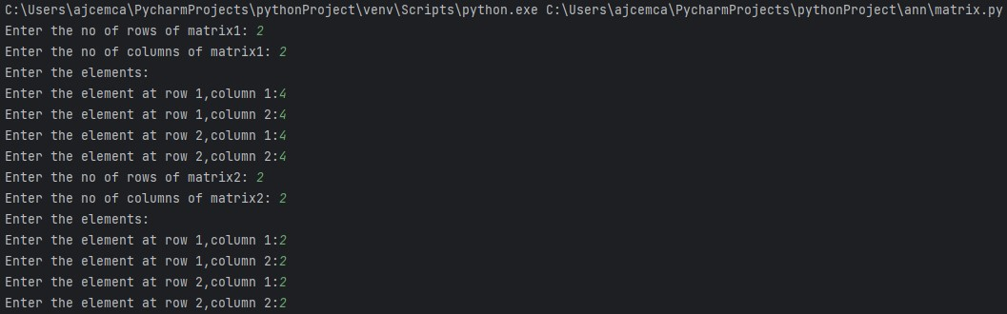

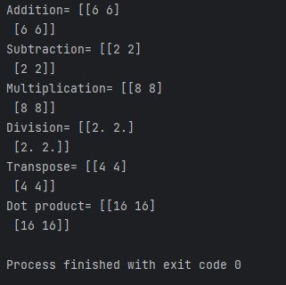

**Result:**

The program was executed and the result was successfully obtained. Thus, CO1 was obtained.

**Experiment No.: 2**

**Aim:** Program to perform single value decomposition using NumPy.

**CO1:** Use different python packages to perform numerical calculations, statistical computations and data visualization

**Procedure**:

import numpy as np

matrix= np.array([[5,6,4],

[2,5,6],

[3,5,6]])

U,S,VT =np.linalg.svd(matrix)

print("U=")

print(U)

print("S=")

print(np.diag(S))

print("VT=")

print(VT)

reconstructed_matrix= np.dot (U, np.dot(np.diag(S), VT))

print("Reconstructed matrix=")

print(reconstructed_matrix)

**Output Screenshot**

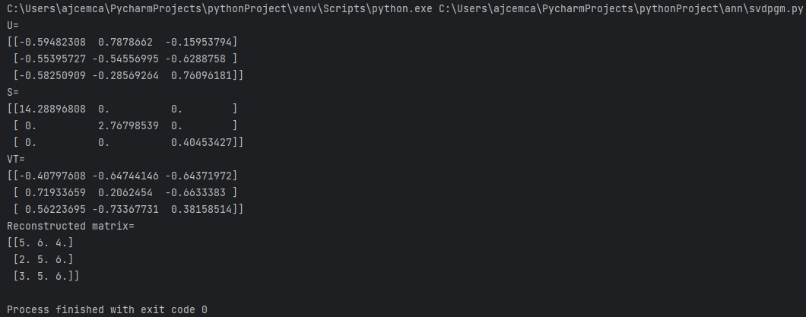

**Result:**

The program was executed and the result was successfully obtained. Thus, CO1 was obtained.

**Experiment No.: 3**

**Aim:** Program to perform data visualisation using the python library matplotlib.

**CO1:** Use different python packages to perform numerical calculations, statistical computations and data visualization.

**Procedure**:

import matplotlib.pyplot as plt

categories = ['Category A','Category B','Category C','Category D']

values = [15,30,22,40]

plt.bar(categories,values,color="pink")

plt.xlabel("Categories")

plt.ylabel("Values")

plt.title("Bar graph")

plt.show()

**Output Screenshot**

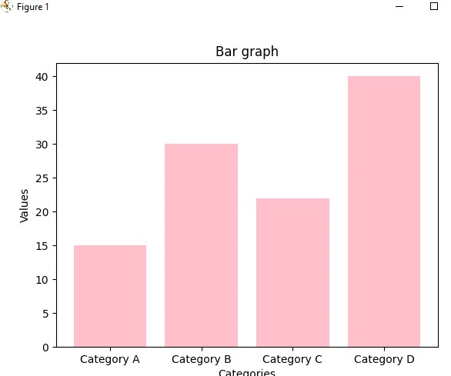

**Result:**

The program was executed and the result was successfully obtained. Thus, CO1 was obtained.

**Experiment No.: 4**

**Aim:** Program to implement KNN classification using any standard dataset available in the public domain and find the accuracy of the algorithm (Iris Dataset)

**CO2:** Use different packages and frameworks to implement regression and classification algorithms.

**Procedure**:

from sklearn.neighbors import KNeighborsClassifier

from sklearn.model_selection import train_test_split

from sklearn.datasets import load_iris

from sklearn.metrics import accuracy_score

iris=load_iris()

x=iris.data

y=iris.target

x_train,x_test,y_train,y_test=train_test_split(x,y,test_size=0.2,random_state=42)

knn=KNeighborsClassifier(n_neighbors=7)

knn.fit(x_train,y_train)

print(knn.predict(x_test))

V=knn.predict(x_test)

result=accuracy_score(y_test, V)

print("accuracy:",result)

**Output Screenshot**

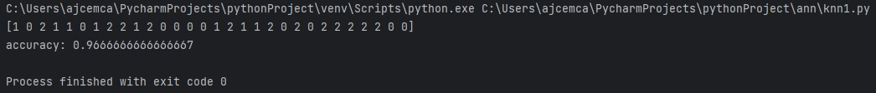

**Result:**

The program was executed and the result was successfully obtained. Thus, CO2 was obtained.

**Experiment No.: 5**

**Aim:** Program to implement KNN classification using any standard dataset available in the public domain and find the accuracy of the algorithm (Load Digits).

**CO2:** Use different packages and frameworks to implement regression and classification algorithms.

**Procedure**:

from sklearn.neighbors import KNeighborsClassifier

from sklearn.model_selection import train_test_split

from sklearn.datasets import load_digits

from sklearn.metrics import accuracy_score

digits=load_digits()

x=digits.data

y=digits.target

x_train, x_test, y_train, y_test=train_test_split(x,y,test_size=0.2,random_state=42)

knn=KNeighborsClassifier(n_neighbors=7)

knn.fit(x_train,y_train)

print(knn.predict(x_test))

V=knn.predict(x_test)

result=accuracy_score(y_test, V)

print("accuracy:",result)

**Output Screenshot**

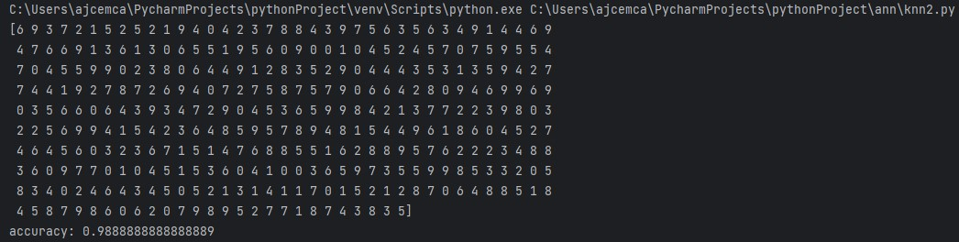

**Result:**

The program was executed and the result was successfully obtained. Thus, CO2 was obtained.

**Experiment No.: 6**

**Aim:** Program to implement Naïve Bayes Algorithm using any standard dataset available in the public domain and find the accuracy of the algorithm (Iris Dataset).

**CO2:** Use different packages and frameworks to implement regression and classification algorithms.

**Procedure**:

from sklearn.model_selection import train_test_split

from sklearn.datasets import load_iris

from sklearn.naive_bayes import GaussianNB

from sklearn.metrics import accuracy_score

iris=load_iris()

x=iris.data

y=iris.target

x_train,x_test,y_train,y_test=train_test_split(x,y,test_size=0.2,random_state=42)

clf=GaussianNB()

clf.fit(x_train,y_train)

print(clf.predict(x_test))

V=clf.predict(x_test)

result=accuracy_score(y_test, V)

print("Accuracy:",result)

**Output Screenshot**



**Result:**

The program was executed and the result was successfully obtained. Thus, CO2 was obtained.

**Experiment No.: 7**

**Aim:** Program to implement Naïve Bayes Algorithm using any standard dataset available in the public domain and find the accuracy of the algorithm (Breast Cancer Dataset).

**CO2:** Use different packages and frameworks to implement regression and classification algorithms.

**Procedure**:

from sklearn.model_selection import train_test_split

from sklearn.datasets import load_breast_cancer

from sklearn.naive_bayes import GaussianNB

from sklearn.metrics import accuracy_score,classification_report

data=load_breast_cancer()

x=data.data

y=data.target

x_train,x_test,y_train,y_test=train_test_split(x,y,test_size=0.2,random_state=42)

clf=GaussianNB()

clf.fit(x_train,y_train)

print(clf.predict(x_test))

V=clf.predict(x_test)

result=accuracy_score(y_test, V)

print("Accuracy:",result)

print()

report=classification_report(y_test,V)

print("Classification report:")

print(report)

**Output Screenshot**

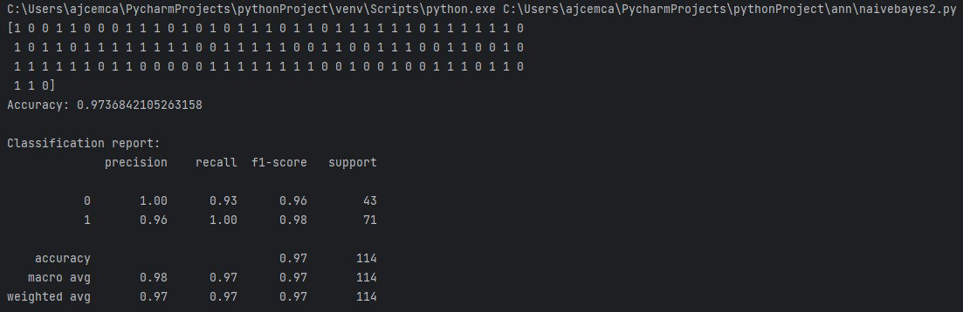

**Result:**

The program was executed and the result was successfully obtained. Thus, CO2 was obtained.

**Experiment No.: 8**

**Aim:** Given one-dimensional dataset represented with NumPy array. Write a program to calculate slope and intercept.

**CO2:** Use different packages and frameworks to implement regression and classification algorithms.

**Procedure**:

import numpy as np

from sklearn.linear_model import LinearRegression

x = np.array([64,75,68,73,78,82,76,85,71,88]).reshape(-1,1)

y = np.array([17,27,15,24,39,44,30,48,19,47])

regressor = LinearRegression()

regressor.fit(x, y)

slope = regressor.coef_[0]

intercept = regressor.intercept_

print(f"Slope(Coefficient): {slope}")

print(f"Intercept: {intercept}")

**Output Screenshot**



**Result:**

The program was executed and the result was successfully obtained. Thus, CO2 was obtained.

**Experiment No.: 9**

**Aim:** Program to implement simple linear regression using any standard dataset available in the public domain and find the r2 score.

**CO2:** Use different packages and frameworks to implement regression and classification algorithms.

**Procedure**:

import pandas as pd

from sklearn.model_selection import train_test_split

from sklearn.linear_model import LinearRegression

from sklearn.metrics import r2_score

import matplotlib.pyplot as plt

data = pd.read_csv('Salary_Data.csv')

x = data['YearsExperience'].values.reshape(-1, 1)

y = data['Salary'].values

x_train, x_test, y_train, y_test = train_test_split(x, y, test_size=0.2, random_state=42)

regressor = LinearRegression()

regressor.fit(x_train, y_train)

print(regressor.predict(x_test))

V = regressor.predict(x_train)

r2 = r2_score(y_train, V)

print("\nR squared:", r2)

plt.scatter(x_test, y_test, color="black", label="data points")

plt.plot(x_train, V, color="blue", linewidth=3, label="Regression line")

plt.xlabel("Years of Experience")

plt.ylabel("Salary")

plt.legend()

plt.show()

**Output Screenshot**

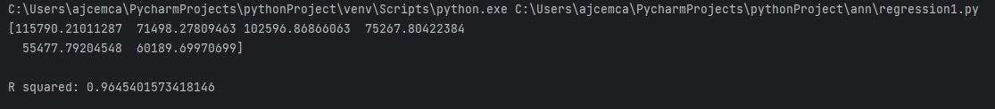

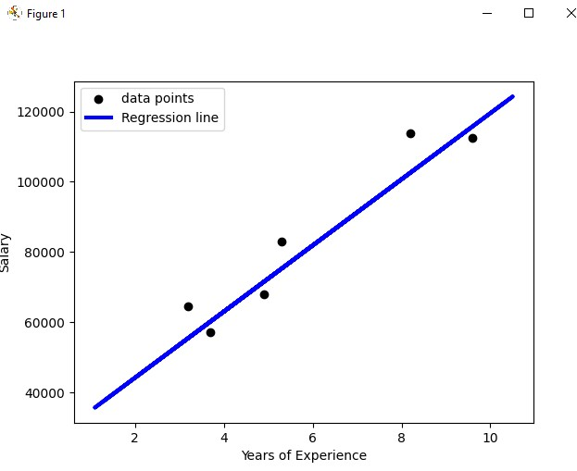

**Result:**

The program was executed and the result was successfully obtained. Thus, CO2 was obtained.

**Experiment No.: 10**

**Aim:** Program to implement multiple linear regression techniques using any standard dataset available in public domain and evaluate its performance.

**CO2:** Use different packages and frameworks to implement regression and classification algorithms.

**Procedure**:

import pandas as pd

from sklearn.datasets import fetch_california_housing

from sklearn.model_selection import train_test_split

from sklearn.linear_model import LinearRegression

from sklearn.metrics import mean_squared_error

california_housing = fetch_california_housing()

df = pd.DataFrame(data = california_housing.data, columns=california_housing.feature_names)

df["Target"] = california_housing.target

x = df.drop('Target', axis=1)

y = df['Target']

x_train, x_test, y_train, y_test = train_test_split(x, y, test_size=0.2, random_state=42)

regressor = LinearRegression()

regressor.fit(x_train, y_train)

v = regressor.predict(x_test)

mse = mean_squared_error(y_test, v)

print("Mean squared error: ", mse)

**Output Screenshot**



**Result:**

The program was executed and the result was successfully obtained. Thus, CO2 was obtained.

**Experiment No.: 11**

**Aim:** Program to implement decision trees using any standard dataset available in the public domain and find the accuracy of the algorithm (Iris Dataset).

**CO3:** Use different packages and frameworks to implement text classification using SVM and clustering using k-means.

**Procedure**:

from sklearn.datasets import load_iris

from sklearn import tree

from sklearn.model_selection import train_test_split

from sklearn.tree import DecisionTreeClassifier

from sklearn.metrics import accuracy_score,classification_report

import matplotlib.pyplot as plt

iris=load_iris()

x=iris.data

y=iris.target

max_depth=3

x_train,x_test,y_train,y_test=train_test_split(x,y,test_size=0.2,random_state=42)

clf=DecisionTreeClassifier(max_depth=max_depth)

clf.fit(x_train,y_train)

plt.figure(figsize=(15,10))

tree.plot_tree(clf,filled=True,feature_names=iris.feature_names)

plt.title("Decision tree")

plt.show()

print(clf.predict(x_test))

V=clf.predict(x_test)

result=accuracy_score(y_test, V)

report=classification_report(y_test,V)

print("Accuracy:",result)

print("Classification report:\n",report)

**Output Screenshot**

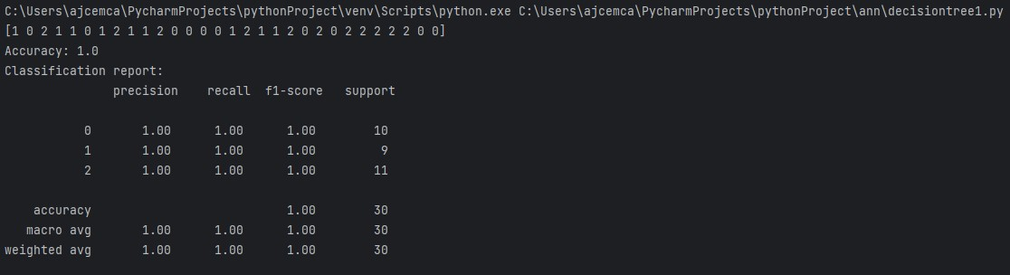

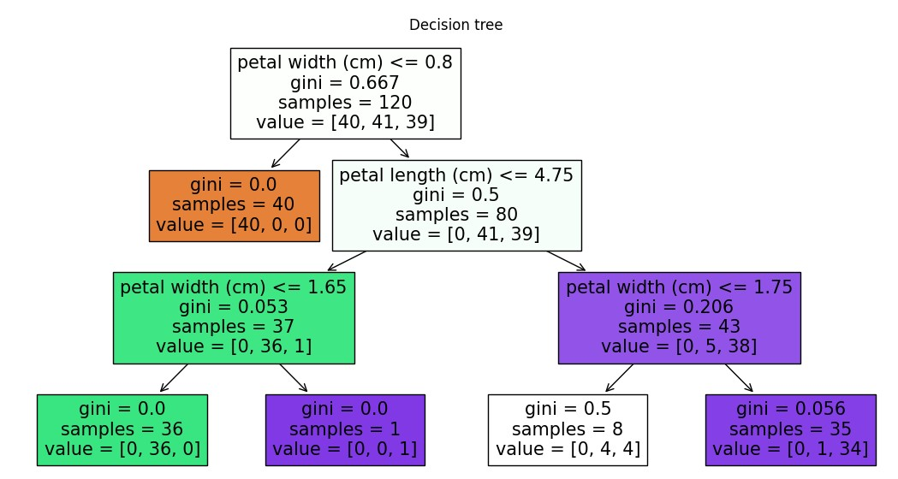

**Result:**

The program was executed and the result was successfully obtained. Thus, CO3 was obtained.

**Experiment No.: 12**

**Aim:** Program to implement decision trees using any standard dataset available in the public domain and find the accuracy of the algorithm (Breast Cancer Dataset)

**CO3:** Use different packages and frameworks to implement text classification using SVM and clustering using k-means

**Procedure**:

from sklearn.datasets import load_breast_cancer

from sklearn.model_selection import train_test_split

from sklearn.tree import DecisionTreeClassifier

from sklearn.metrics import accuracy_score,classification_report

from sklearn import tree

import matplotlib.pyplot as plt

data=load_breast_cancer()

x=data.data

y=data.target

max_depth=3

x_train,x_test,y_train,y_test=train_test_split(x,y,test_size=0.2,random_state=42)

clf=DecisionTreeClassifier(max_depth=max_depth)

clf.fit(x_train,y_train)

plt.figure(figsize=(15,10))

tree.plot_tree(clf,filled=True,feature_names=data.feature_names)

plt.title("Decision tree")

plt.show()

print(clf.predict(x_test))

V=clf.predict(x_test)

result=accuracy_score(y_test, V)

report=classification_report(y_test,V)

print("Accuracy:",result)

print("Classification report:\n",report)

**Output Screenshot**

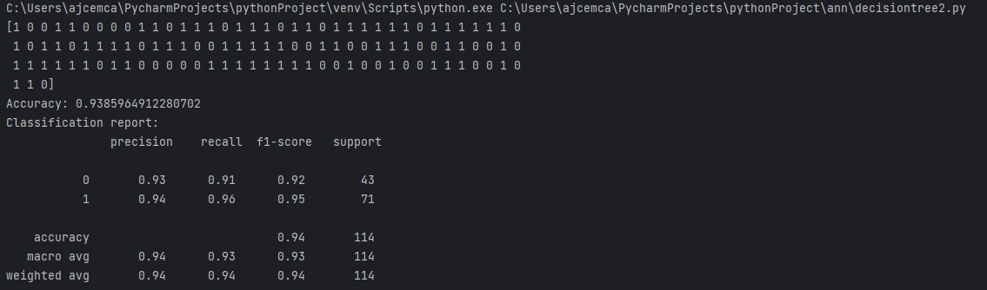

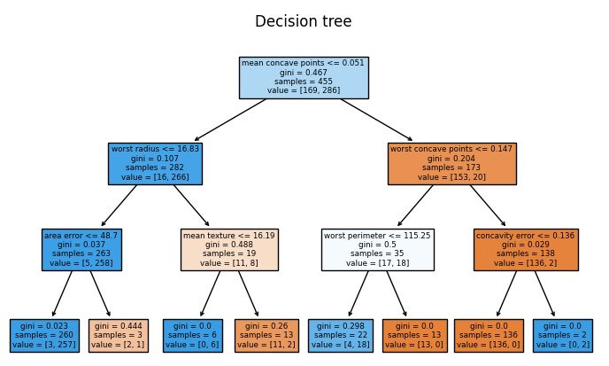

**Result:**

The program was executed and the result was successfully obtained. Thus, CO3 was obtained.

**Experiment No.: 13**

**Aim:** Program to implement k-means clustering technique using any standard dataset available in the public domain (Iris Dataset)

**CO3:** Use different packages and frameworks to implement text classification using SVM and clustering using k-means

**Procedure**:

from sklearn.datasets import load_iris

from sklearn.cluster import KMeans

import matplotlib.pyplot as plt

iris = load_iris()

x = iris.data

y = iris.target

kmeans = KMeans(n_clusters=3, random_state=42)

kmeans.fit(x)

cluster_labels = kmeans.labels_

print(cluster_labels)

centroids = kmeans.cluster_centers_

print(centroids)

plt.scatter(x[:, 0], x[:, 1], c=cluster_labels, cmap="Blues", marker="o", edgecolors="black")

plt.scatter(centroids[:, 0], centroids[:, 1], marker="*", s=200, c="red", label="centroids")

plt.xlabel(iris.feature_names[0])

plt.ylabel(iris.feature_names[1])

plt.title("K means of iris dataset")

plt.legend()

plt.show()

**Output Screenshot**

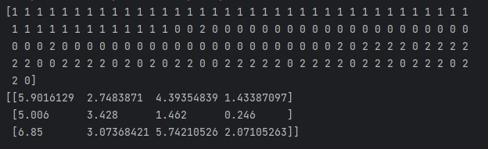

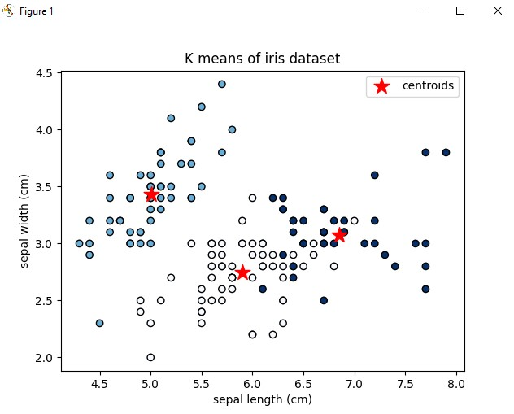

**Result:**

The program was executed and the result was successfully obtained. Thus, CO3 was obtained.

**Experiment No.: 14**

**Aim:** Program to implement k-means clustering technique using any standard dataset available in the public domain (Breast Cancer Dataset)

**CO3:** Use different packages and frameworks to implement text classification using SVM and clustering using k-means

**Procedure**:

from sklearn.datasets import load_breast_cancer

from sklearn.cluster import KMeans

import matplotlib.pyplot as plt

data = load_breast_cancer()

x = data.data

y = data.target

kmeans = KMeans(n_clusters=3, random_state=42)

kmeans.fit(x)

cluster_labels = kmeans.labels_

print(cluster_labels)

centroids = kmeans.cluster_centers_

print(centroids)

plt.scatter(x[:, 0], x[:, 1], c=cluster_labels, cmap="Blues", marker="o", edgecolors="black")

plt.scatter(centroids[:, 0], centroids[:, 1], marker="*", s=200, c="red", label="centroids")

plt.xlabel(data.feature_names[0])

plt.ylabel(data.feature_names[1])

plt.title("K means of breast cancer dataset")

plt.legend()

plt.show()

**Output Screenshot**

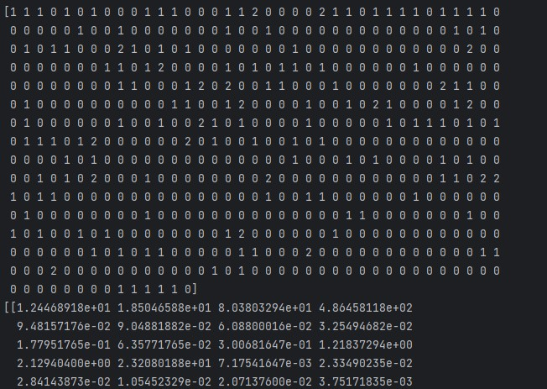

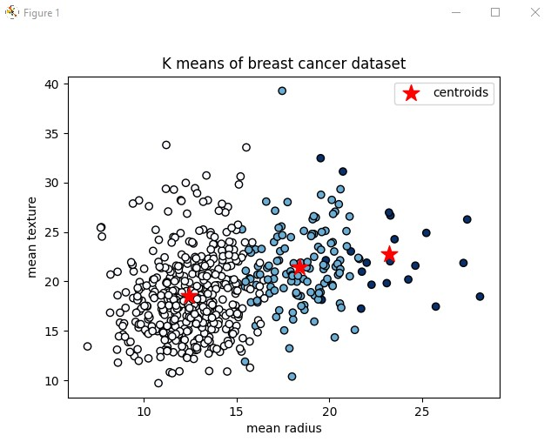

**Result:**

The program was executed and the result was successfully obtained. Thus, CO3 was obtained.

**Experiment No.: 15**

**Aim:** Program to implement text classification using support vector machine.

**CO3:** Use different packages and frameworks to implement text classification using SVM and clustering using k-means

**Procedure**:

from sklearn.datasets import fetch_20newsgroups

from sklearn.feature_extraction.text import TfidfVectorizer

from sklearn.model_selection import train_test_split

from sklearn.svm import SVC

from sklearn.metrics import accuracy_score,classification_report

categories = ['alt.atheism', 'soc.religion.christian', 'comp.graphics', 'sci.med']

twenty_train = fetch_20newsgroups(subset="train", categories=categories, shuffle=True, random_state=42)

vectorizer = TfidfVectorizer()

x_train_tfidf = vectorizer.fit_transform(twenty_train.data)

# print(x_train_tfidf)

y_train = twenty_train.target

x_train, x_test, y_train, y_test = train_test_split(x_train_tfidf, y_train, test_size=0.3, random_state=42)

svm_classifier = SVC(kernel='linear', random_state=42)

svm_classifier.fit(x_train, y_train)

prediction = svm_classifier.predict(x_test)

accuracy = accuracy_score(y_test, prediction)

report = classification_report(y_test,prediction,target_names=twenty_train.target_names)

print("Accuracy = ",accuracy)

print("Classification report =")

print(report)

new_data=[

"I have a question about computer graphics"

]

x_new=vectorizer.transform(new_data)

newprediction=svm_classifier.predict(x_new)

predicted_category=twenty_train.target_names[newprediction[0]]

print("Predicted category:", predicted_category)

**Output Screenshot**

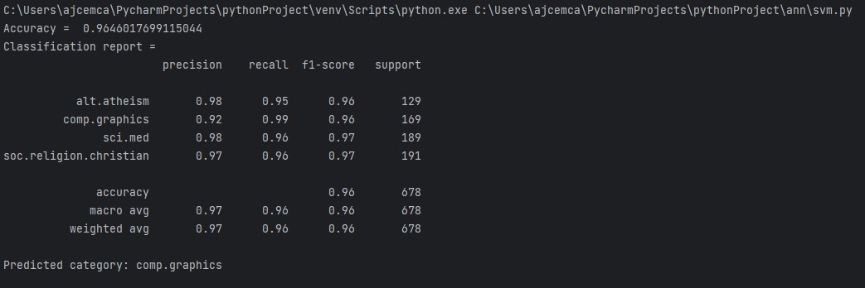

**Result:**

The program was executed and the result was successfully obtained. Thus, CO3 was obtained.

**Experiment No.: 16**

**Aim:** Program on artificial neural network to classify images from any standard dataset in the public domain using Keras framework.

**CO4:** Implement convolutional neural network algorithm using Keras framework.

**Procedure**:

import tensorflow as tf

from tensorflow.keras.datasets import mnist

from tensorflow.keras.models import Sequential

from tensorflow.keras.layers import Dense, Flatten

from tensorflow.keras.utils import to_categorical

# Load the MNIST dataset

(X_train, y_train), (X_test, y_test) =mnist.load_data()

# Normalize pixel values to be between 0 and 1

X_train = X_train / 255.0

X_test = X_test / 255.0

# Flatten the images (convert 28x28 images to 1D vectors)

X_train = X_train.reshape(-1, 28 * 28)

print(X_train)

X_test = X_test.reshape(-1, 28 * 28)

print(X_train)

# One-hot encode the target labels

y_train = to_categorical(y_train)

y_test = to_categorical(y_test)

print(y_test)

# Create a simple feedforward neural network model

model=Sequential([

Dense(128, activation='relu', input_shape=(28 * 28,)),

Dense(68, activation='relu'),

Dense(10, activation='softmax')

])

model.compile(optimizer='adam', loss='categorical_crossentropy', metrics=['accuracy'])

model.fit(X_train,y_train, epochs=5 , batch_size=32, validation_split=0.2)

loss, accuracy= model.evaluate(X_test,y_test)

print(accuracy)

**Output Screenshot**

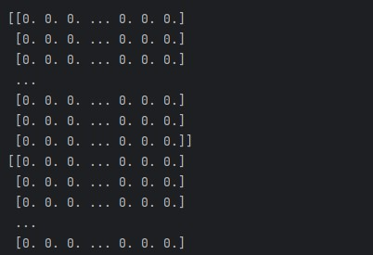

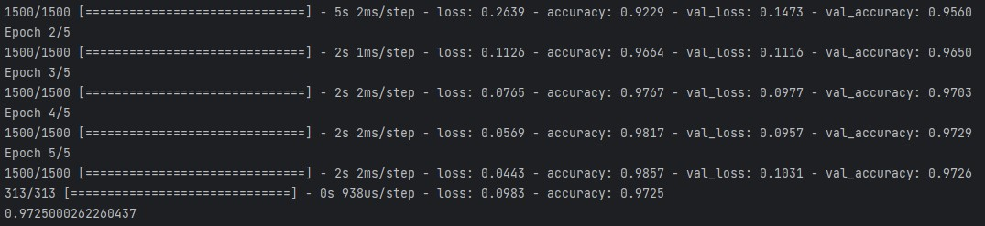

**Result:**

The program was executed and the result was successfully obtained. Thus, CO4 was obtained.

**Experiment No.: 17**

**Aim:** Program to implement a simple web crawler and scrapping web pages.

**CO5:** Implement programs for web data mining and natural language processing using NLTK.

**Procedure**:

import requests

def simple_scraper(url):

response = requests.get(url)

if response.status_code == 200:

print("Content")

print(response.text)

else:

print("Failed to fetch the page. Status_code:", response.status_code)

url_to_scrap = 'http://ajce.in'

simple_scraper(url_to_scrap)

**Output Screenshot**

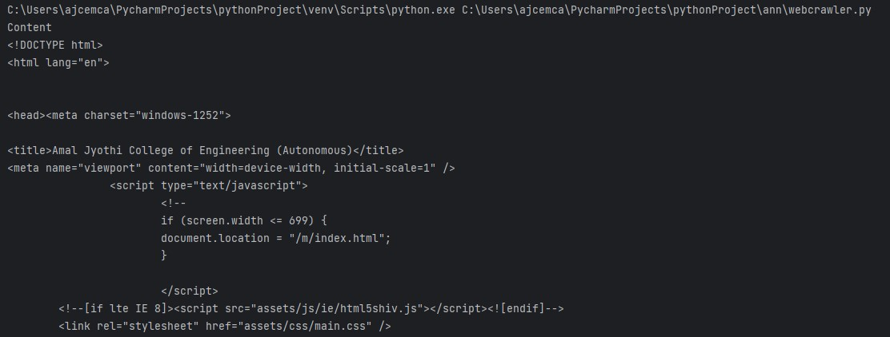

**Result:**

The program was executed and the result was successfully obtained. Thus, CO5 was obtained.

**Experiment No.: 18**

**Aim:** Program to implement a simple web crawler and parse the content using BeautifulSoup.

**CO5:** Implement programs for web data mining and natural language processing using NLTK.

**Procedure**:

import requests

from bs4 import BeautifulSoup

def simple_scraper_with_bs(url):

response = requests.get(url)

if response.status_code == 200:

soup = BeautifulSoup(response.content, 'html.parser')

print("Title:", soup.title.string)

print("Content")

print(soup.get_text())

else:

print("Failed to fetch the page. Status_code:", response.status_code)

url_to_scrap = 'http://ajce.in'

simple_scraper_with_bs(url_to_scrap)

**Output Screenshot**

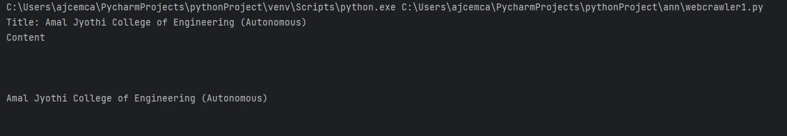

**Result:**

The program was executed and the result was successfully obtained. Thus, CO5 was obtained.

**Experiment No.: 19**

**Aim:** Implement problems on natural language processing - Part of Speech tagging, N-gram & smoothening and Chunking using NLTK

**CO5:** Implement programs for web data mining and natural language processing using NLTK.

**Procedure**:

import nltk

nltk.download('punkt')

nltk.download('brown')

nltk.download('averaged_perceptron_tagger')

from nltk.tokenize import word_tokenize

from nltk.util import ngrams

from nltk.corpus import brown

from nltk.chunk import RegexpParser

sentence = "The quick brown fox jumps over the lazy dog"

tokens = word_tokenize(sentence)

print(tokens)

pos_tags = nltk.pos_tag(tokens)

print("Part of Speech Tagging")

print(pos_tags)

text = brown.words(categories='news')[:1000]

bigrams = list(ngrams(text, 2))

freq_dist = nltk.FreqDist(bigrams)

print("\nN-gram Analysis(Bigram with Smoothening)")

for bigram in bigrams:

print(f"{bigram}:{freq_dist[bigram]}")

tagged_sentence = nltk.pos_tag(word_tokenize("The quick brown fox jumps over the lazy dog"))

grammar = r"NP:{<DT>?<JJ>*<NN>}"

cp = RegexpParser(grammar)

result = cp.parse(tagged_sentence)

print("\nChunking with Regular Expression and POS tags")

print(result)

**Output Screenshot**



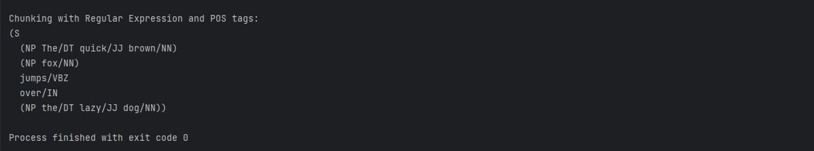

**Result:**

The program was executed and the result was successfully obtained. Thus, CO5 was obtained.